USER MANUEL & INSTRUCTIONS

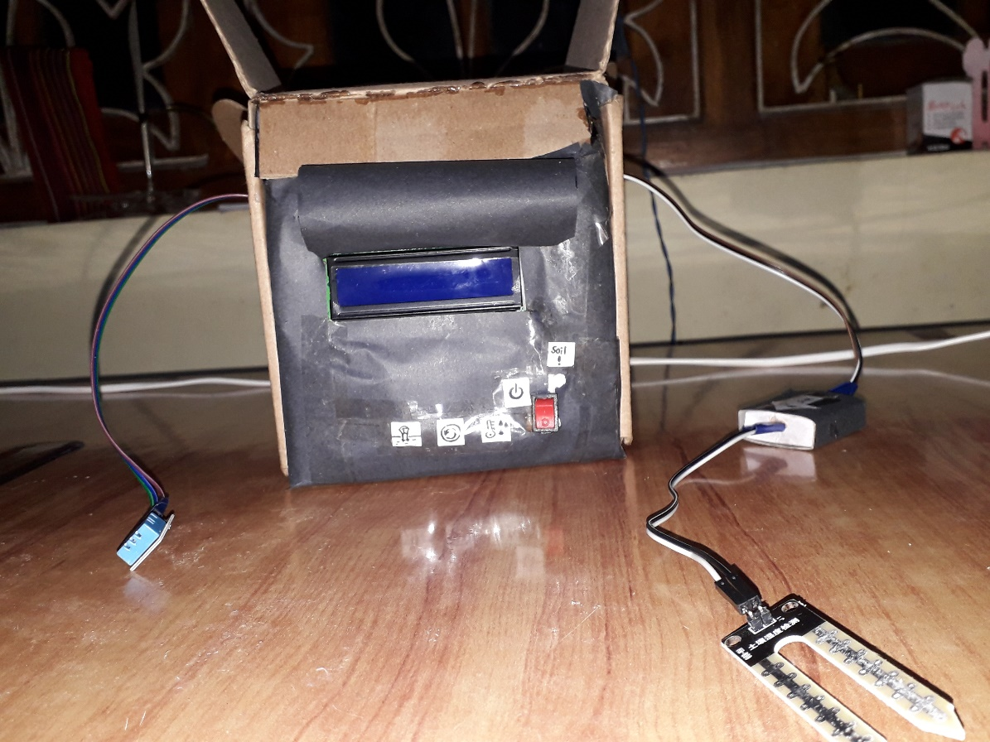COMPOST BIN DATA INDICATOR 1.0

Month: August

Version: 1.0.0

# INTENDED USE

Although compost is produced around the globe, they need to be produced by suppling several conditions which should be satisfied to produce quality compost.

Sound temperature required aeration and water content in the composting medium are major factors affecting the quality production of compost. Microorganisms should be facilitated with the favorable conditions they need to produce compost. Having a clear idea on the above factors would make the production of compost more efficient and quality one. It would be a better act if the compost maker could know about the progress of the compost bin to get prepared to add the necessities lacking in the compost bin. This “Compost bin data indicator” is an instrument composed of two sensors measuring the temperature and humidity inside the compost bin and moisture of the medium to check whether the compost is missing the amount of water that should be sustained.

# FEATURES

* 2 buttons to switch in between the data
* 16×2 LCD display where you can view the data clearly
* Calibratable soil moisture sensor.
* Can be powered by a 9V battery
* LED indicator monitoring the soli moistures (LED is turned on when soil moisture is <40% and >60%)
* 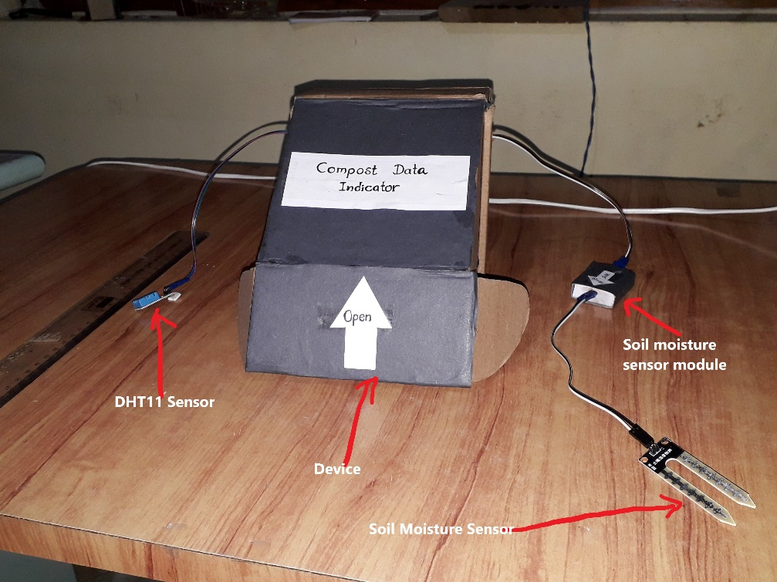The unit is supplied with an adjustable cover for keeping in outdoors

**Figure 2‑1: Main components of the device**

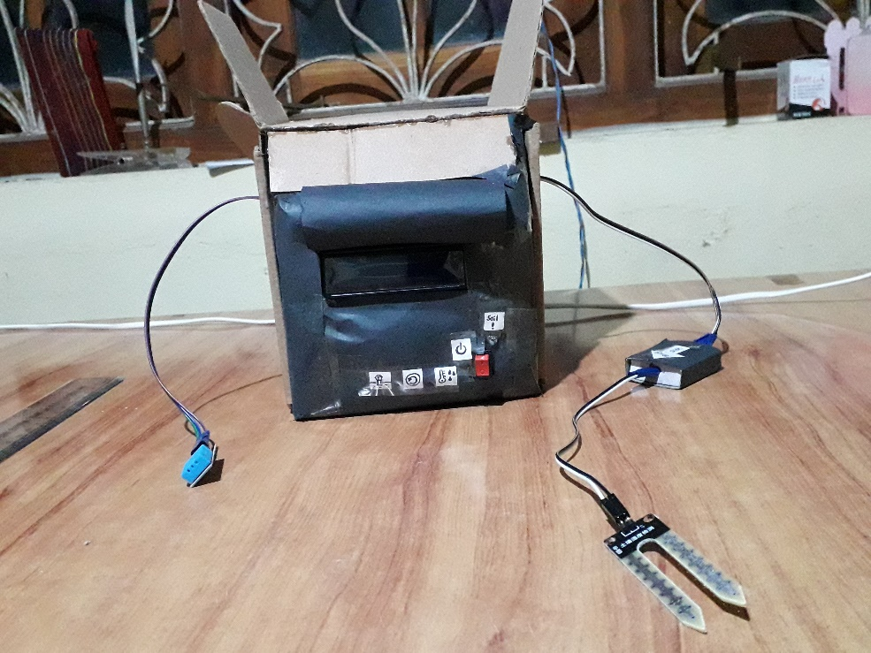

**Figure 2‑2: Forward view of the device**

# HOW TO USE

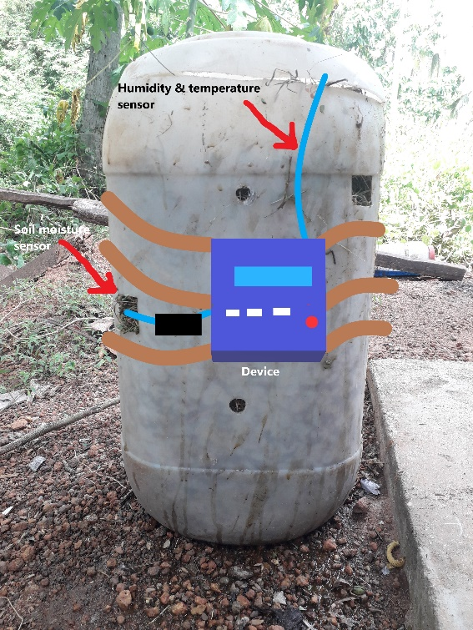

**Figure 3‑1 : Fixing your compost indicator**

* First tie up your indicator around your bin or else fix it with some stand in an unmovable position.
* Then fix your humidity sensor part in the lid of the bin and fix it unmovable.
* The immerse the electrodes of the soil moisture sensor at the middle of your bin to get a fair reading, get multiple reading for better results
* Read your data from the LCD panel.

User interface is composed of 4 buttons and one LED indicator.

**Table 1: Icons used in device**

|  |  |
| --- | --- |
| **Symbol** | **Function** |
|  | Power |
|  | Reset |
|  | Temperature & Humidity |
|  | Soil Moisture |
|  | Battery cover |

**The humidity & temperature sensor can measure from 20-90% of relative humidity and 0-50 ̊C.**

# POWER

* Device works on 5V DC voltage
* Use 9V batteries

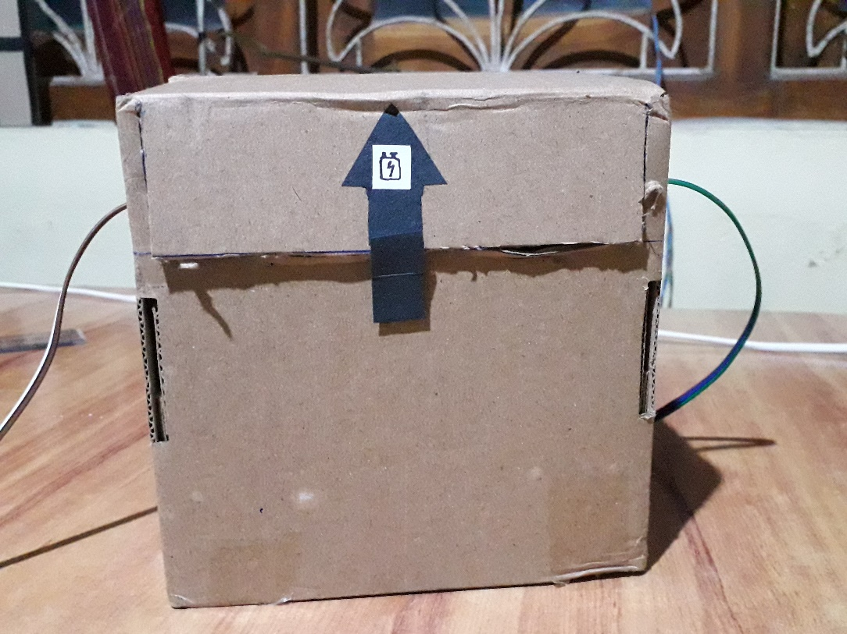

**Figure 4‑1: Pull up from here to replace batteries**

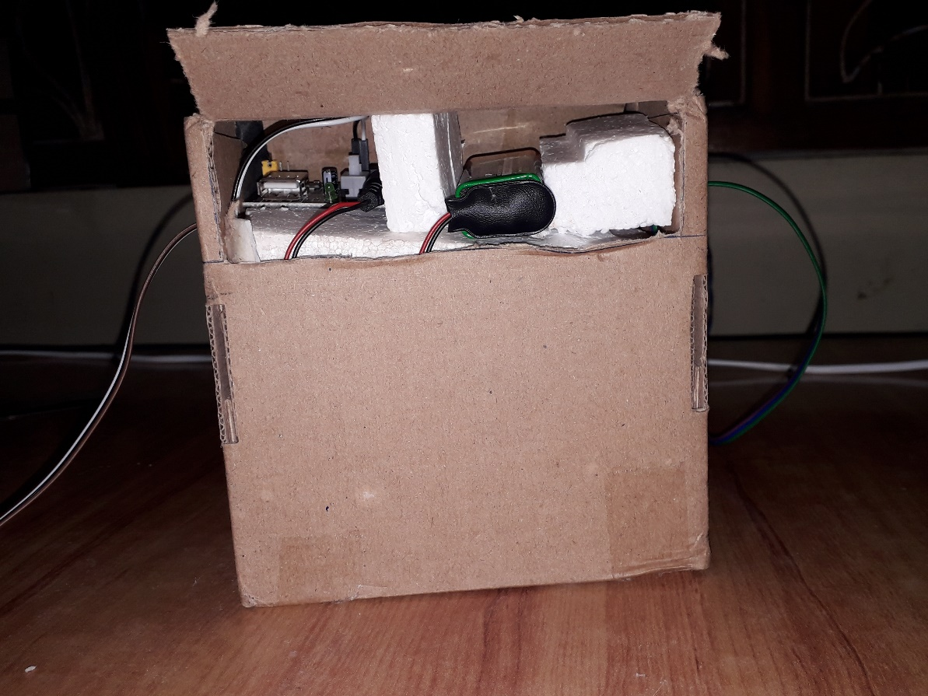

**Figure 4‑2: Clip up your 9V battery here**